
Green University of Bangladesh
Department of Computer Science and Engineering(CSE)
Faculty of Sciences and Engineering
Semester: (Spring, Year:2024), B.Sc. in CSE (Day)

LAB ASSIGNMENT NO #04
Course Title: Data Communication Lab
Course Code: CSE 308 Section: 221_D3

Lab Experiment Name: Implementing Cyclic Redundancy Check and Parity
Checker

Student Details

Name |  | ID
1. | Jahidul Islam | 221002504

Lab Date : 09 – 03 – 2024
Submission Date : 22 – 03 – 2024
Course Teacher’s Name : Sakhaouth Hossan

[For Teachers use only: Don’t Write Anything inside this box]

Lab Report Status
Marks: ………………………………… Signature:.....................
Comments:.............................................. Date:..............................

1. TITLE OF THE LAB EXPERIMENT:

Implementing Cyclic Redundancy Check and Parity Checker

2. OBJECTIVES:

After complementing this lab experiment, we will gain practical knowledge and tthe outcomes of this experiment are
- To implement the parity checker.

3. PROCEDURE:

The procedure step by step:

- Input:
  - The program starts by taking input, which is a binary string s.
- Initialization:
  - It initializes a vector data to store characters of the input string s.
  - It initializes an integer variable strSize to store the size of the input string s.
- Copying String to Vector:
  - The program then copies each character of the input string s into the vector data.
- Counting Ones:
  - It counts the number of ones in the binary string by iterating through the vector data. This count is stored in the variable cnt.
- Manipulation Based on Count:
  - If the count of ones cnt is even, it adds a '1' at the end of the binary string.
  - If the count of ones cnt is odd, it adds a '0' at the end of the binary string.
- Printing Result:
  - Finally, it prints the modified binary string stored in the vector data.

4. IMPLEMENTATION

// Bismillahir Rahmanir Rahim
// jahidulZaid
#include <bits/stdc++.h>
using namespace std;
#define optimize() ios_base::sync_with_stdio(0);cin.tie(0);cout.tie(0);
#define endl '\n'
#define tt long long t; cin >> t;
#define ll long long
#define pb push_back

// #ifdef LOCAL
// #include "debug.h"
// #endif

// #ifdef ONLINE_JUDGE
// #include "debug.h"
// #endif

int main() {
string s;
cin >> s;
int strSize = s.size();

vector<char>data(strSize);

for(int i = 0;i<strSize;i++){
data[i] = s[i];
}
int cnt = 0;
for (int i = 0; i < strSize; i++) {
if (data[i] == '1') {
cnt++;
}
}
int c = strSize + 1;
if (cnt % 2 == 0) {
/*
ths block add 1/0 at the begining of the string.
it needs to declare the vec size +1
for (int i = c, j = c - 1; i > 0; i--, j--) {
data[i] = data[j];
}
*/
// adds 1 at the end
data.push_back('1');
} else {
/*
ths block add 1/0 at the begining of the string.
it needs to declare the vec size +1
for (int i = c, j = c - 1; i > 0; i--, j--) {
data[i] = data[j];
}
*/
data.push_back('0');
}
for(auto x: data){
cout << x;
}
cout<< endl;
return 0;
}

………….. Continued …………

5. OUTPUT

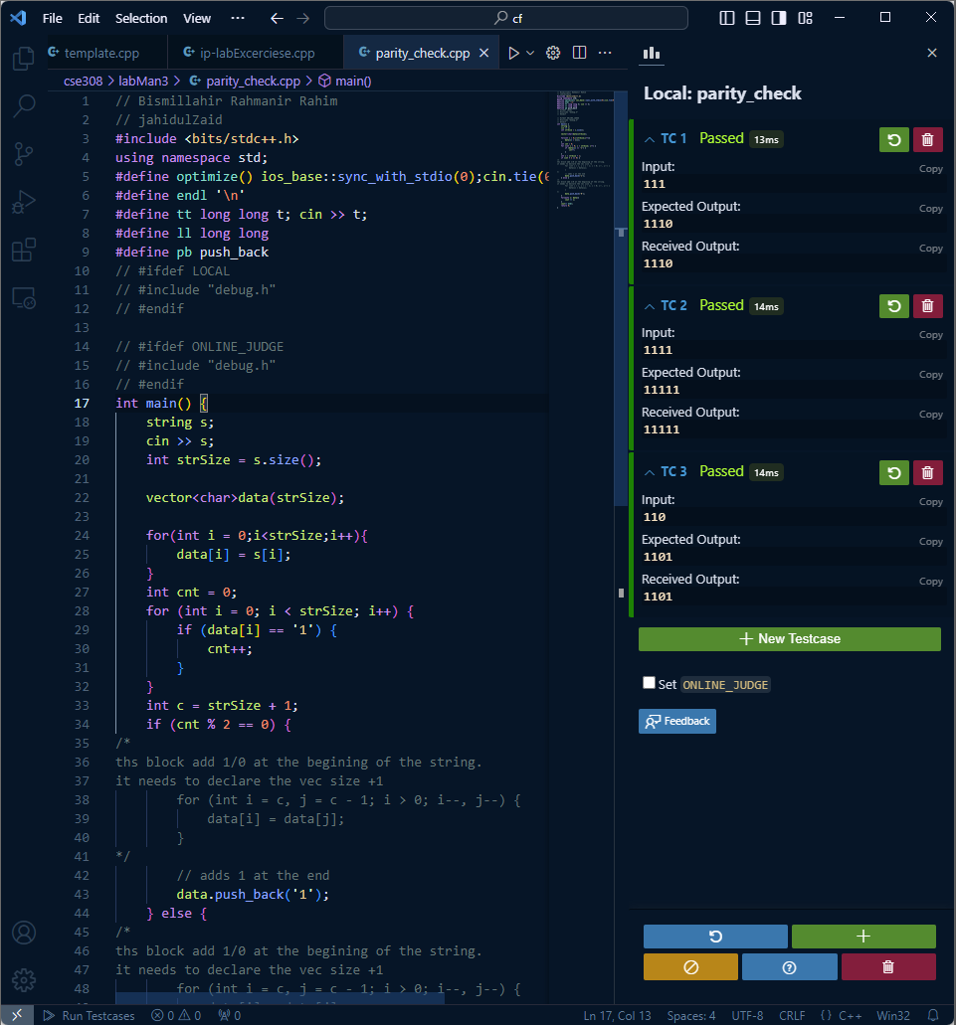

Figure 01: Shows the code and output of this code.
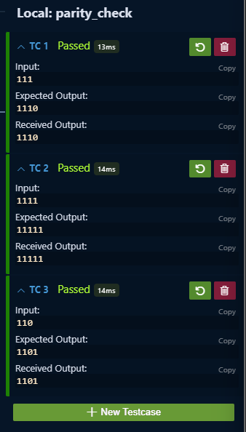

Figure 02: Output of the program.

6. ANALYSIS AND DISCUSSION:

- Both blocks of code add '1' or '0' at the beginning of the binary string based on whether the count of ones cnt is even or odd.

